

Design and Functional Specification

Version 1.0

February 27, 2014

Table of Contents

Project Overview: 2

Draft

People working on the Project: 2

Location 2

Adult Supervision 2

Menu Flow: 3

Menu Wireframes: 4

Characters: 7

Game Center Integration 7

Achievements: 7

Leaderboards 8

Social Integration 8

iCloud Integration 8

Game Elements 8

Coins/points 8

Obstacles 9

Scenes 9

# Project Overview:

School Escape is a game for the iPhone. The goal of the game is to not be caught by the dean of students that is chasing the character through the school. It is a 2D side scrolling game with a single control. Tap anywhere on the screen to jump and avoid obstacles or to jump onto platforms.

## People working on the Project:

* Conrad Koehler – Designer
* Jon Kotz – Developer/ Manager
* Max Greenwald – Developer
* Ben Chaimberg – Developer
* Hannah Mahon - Developer
* Parker Thurstin – Idea man and beta tester
* Delaney Lytle – Artist (not part of March Intensive group)

## Location

Undecided at this time

## Adult Supervision

Undecided at this time

# Menu Flow:

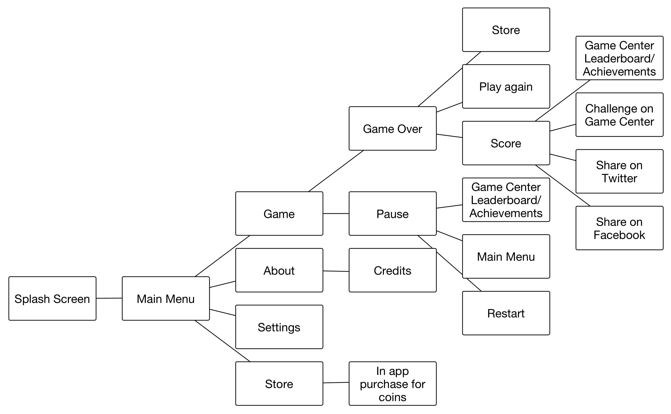

# Menu Wireframes:

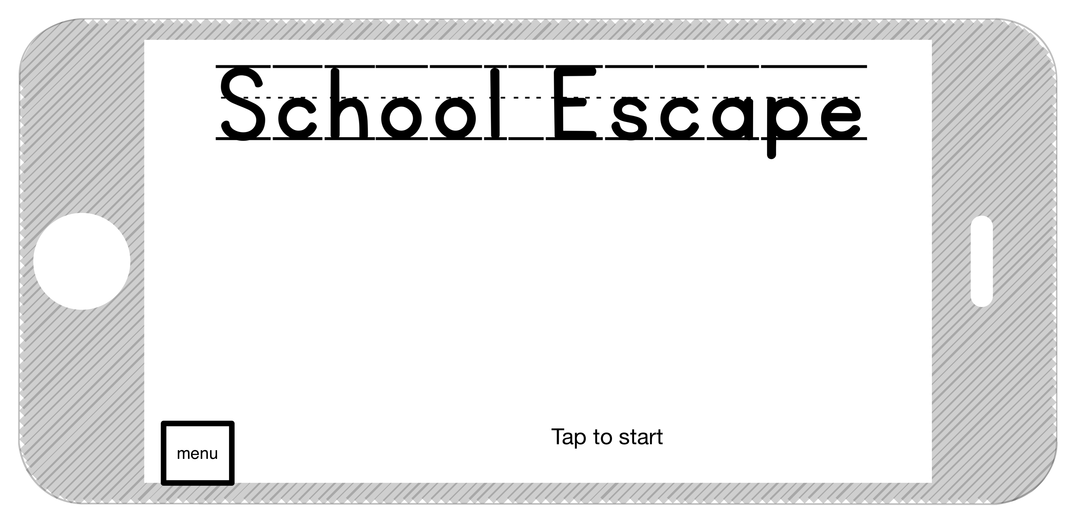

Figure : Main Menu

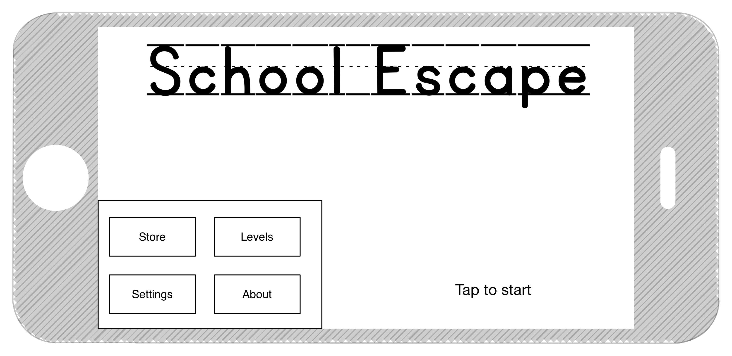

Figure : Main Menu pop-up

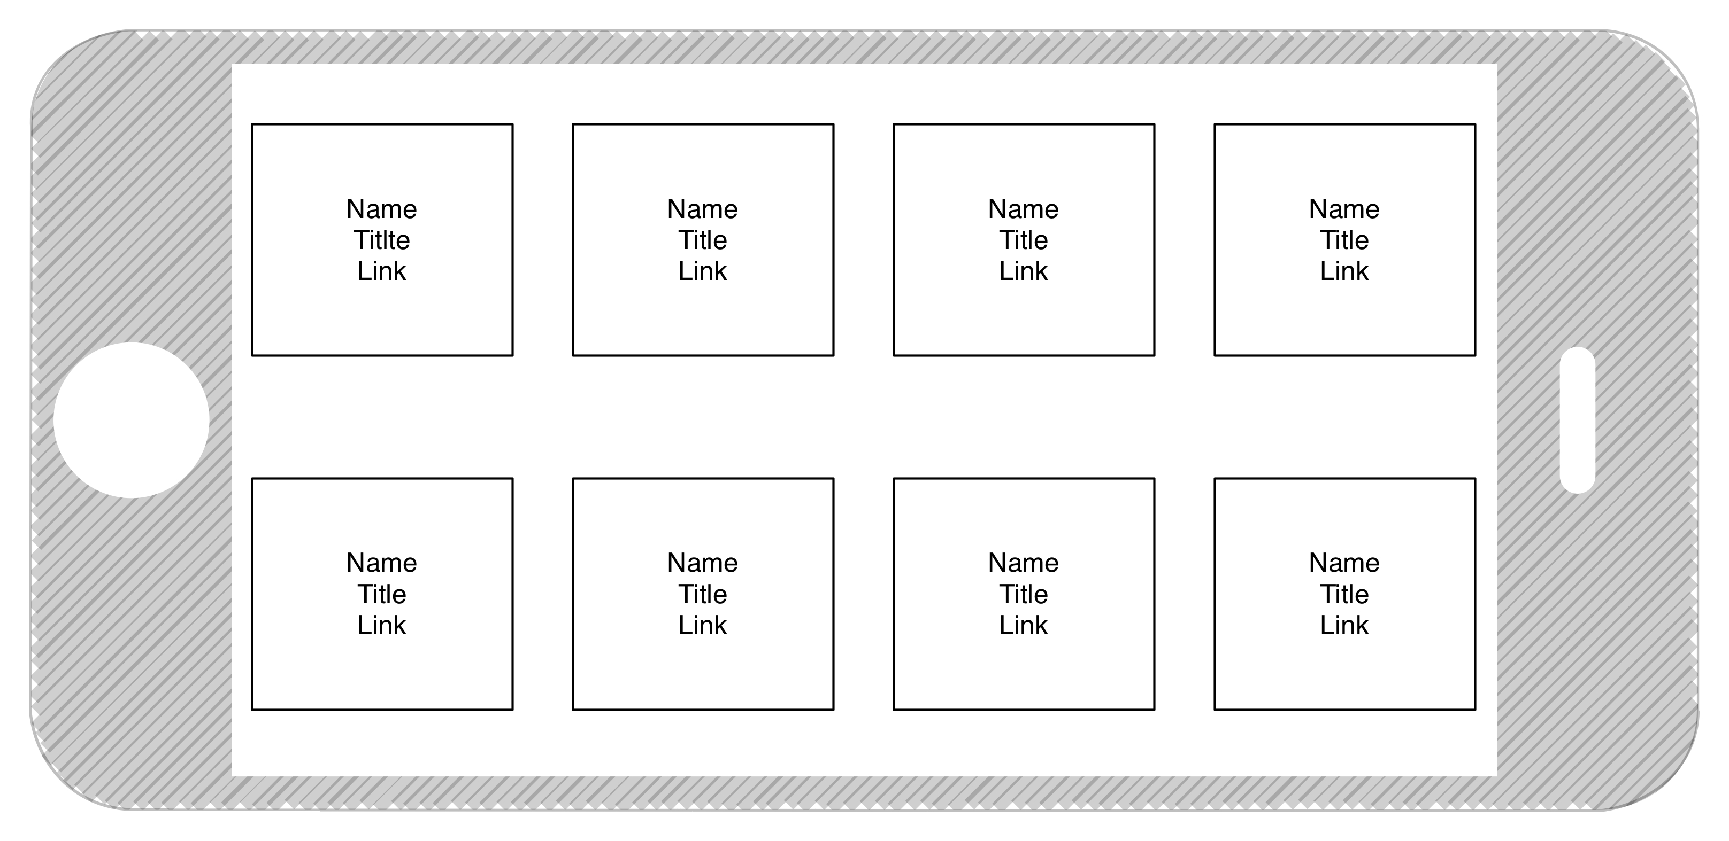

Figure : Credits

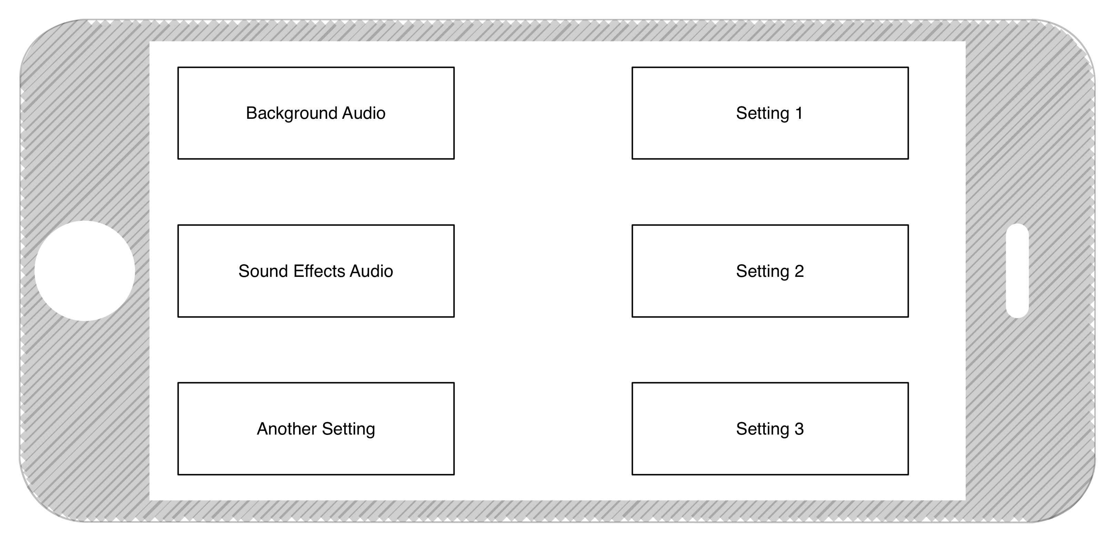

Figure : Settings

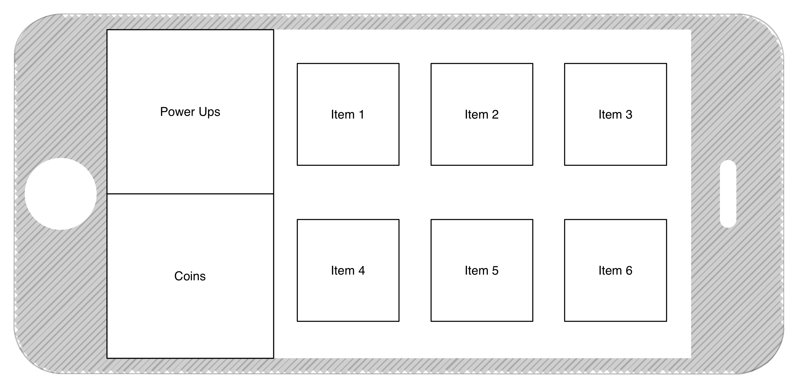

Figure : Store

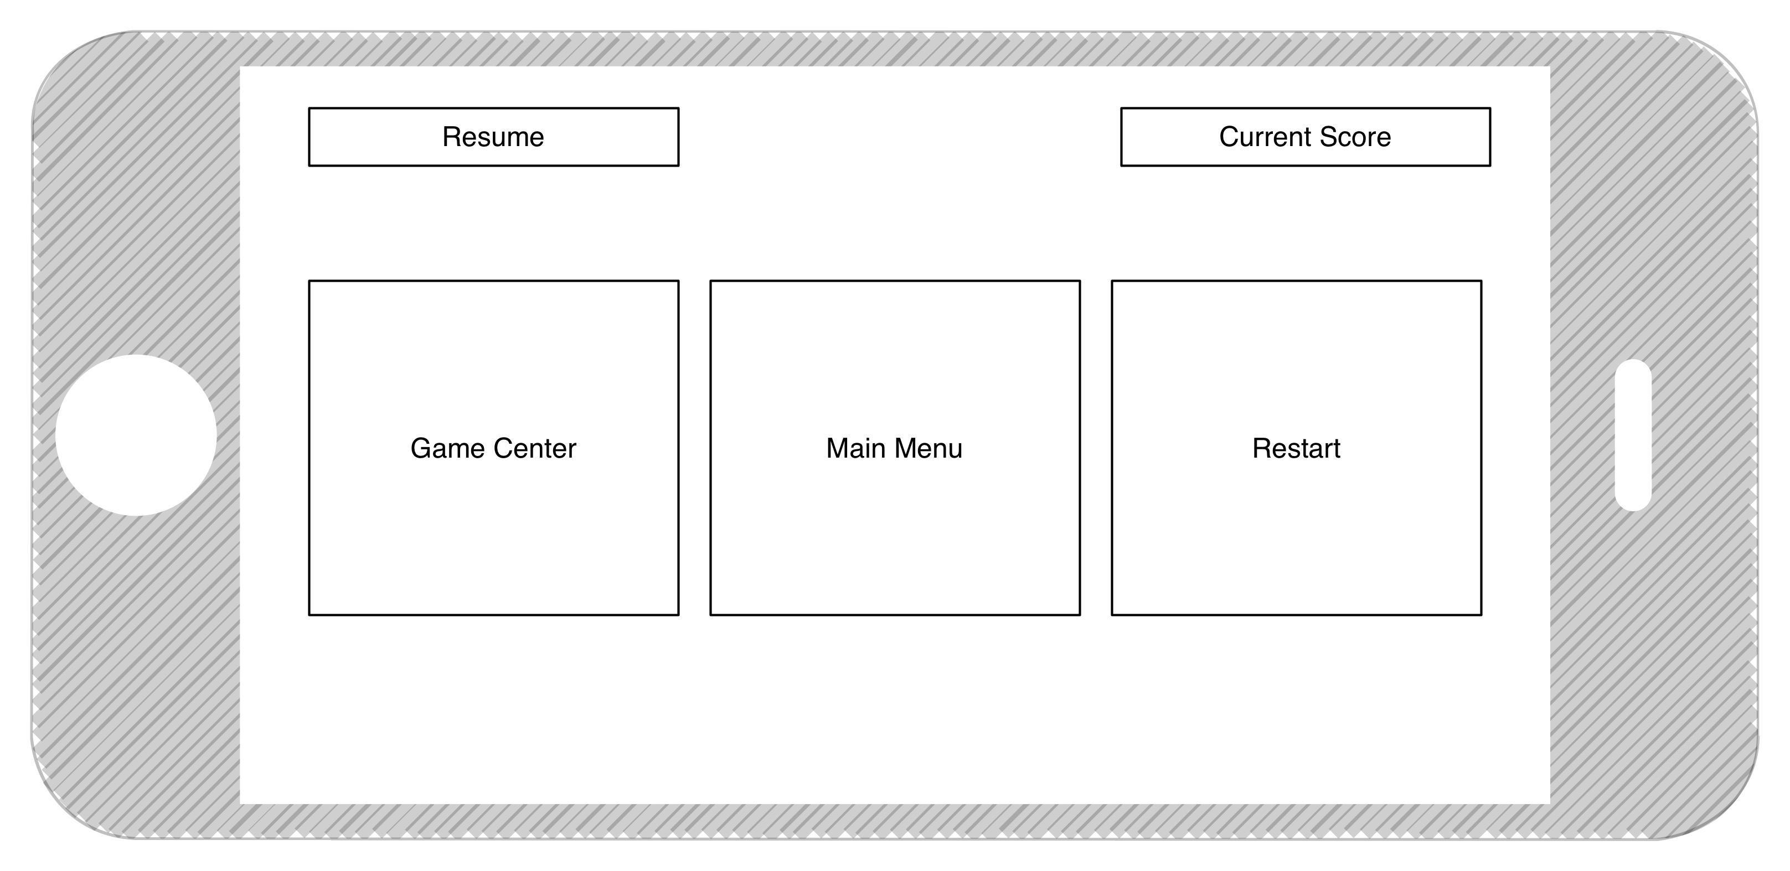

Figure : Pause

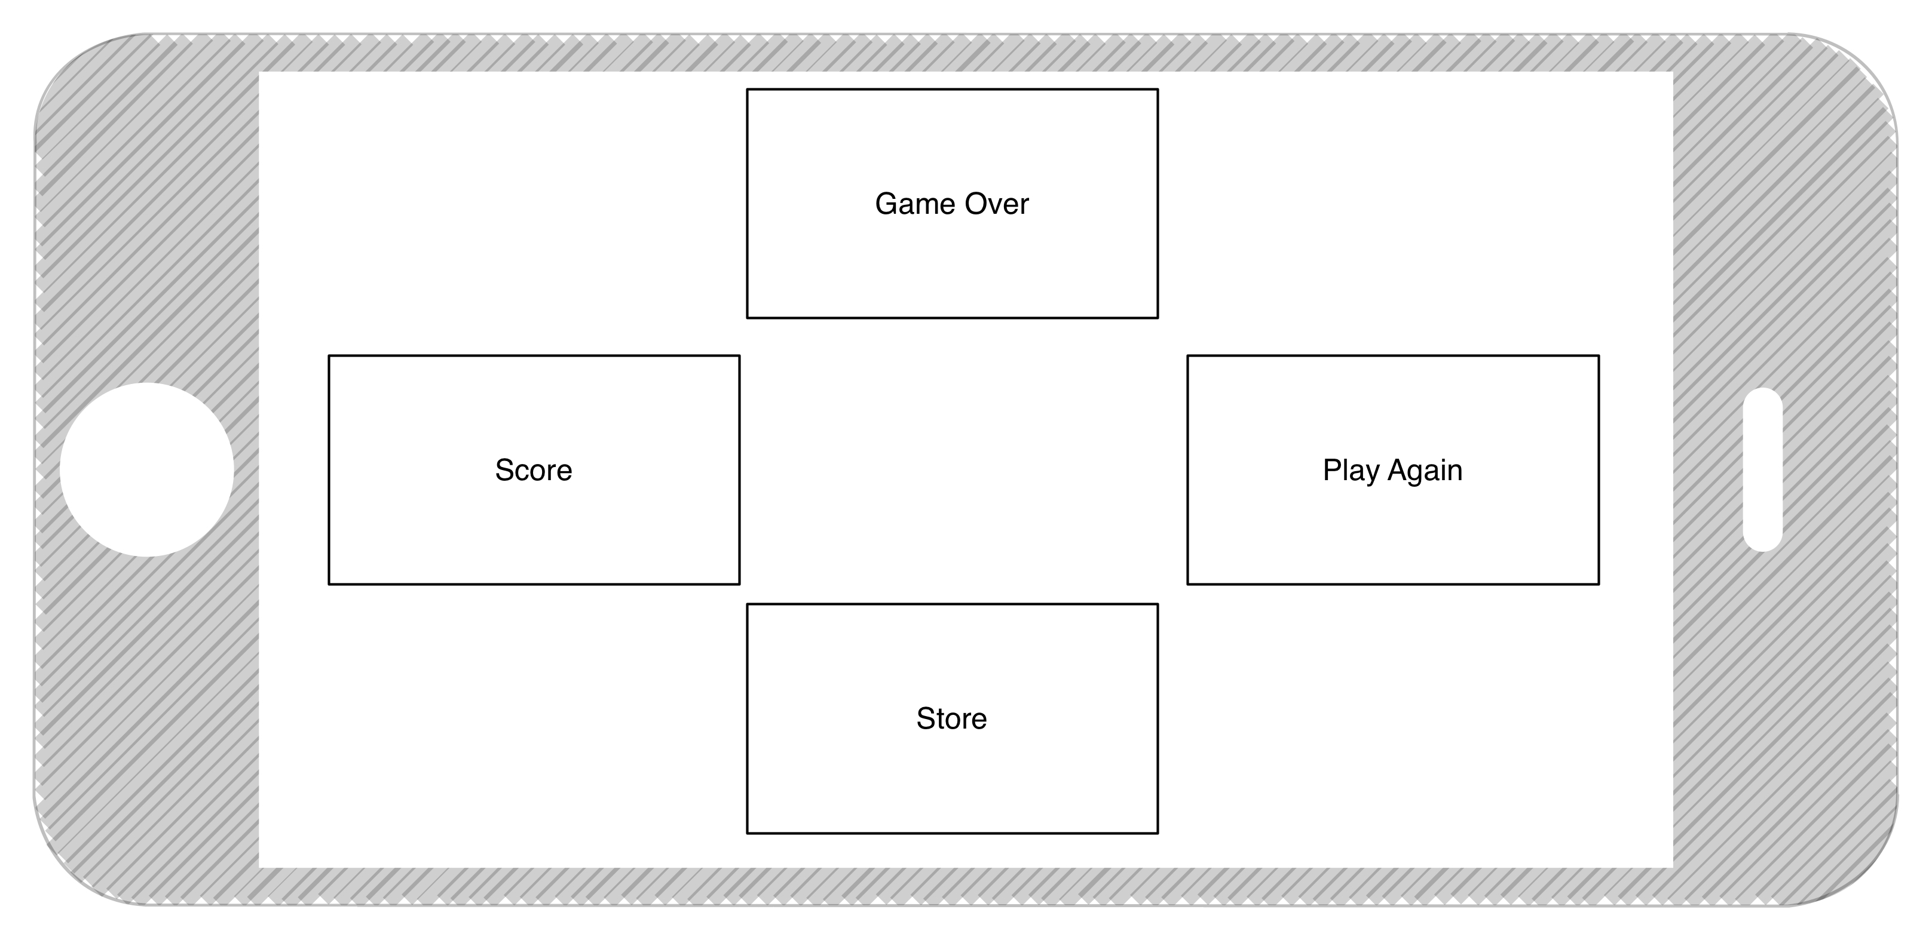

Figure : Game Over

# Characters:

* Male and Female for the main characters
* Evil Teacher/Dean to chase the main character
* Female Teacher to jump out and create an obstacle
* Male Teacher to jump out and create an obstacle

# Game Center Integration

Game center will be integrated tightly with School Escape. After every game the user will be encouraged to challenge friends on Game Center. There will be leaderboards to see what the High Scores are and where your friends stand in relationship to the user.

## Achievements:

* Reach 100 points
* Reach 500 points
* Reach 1000 points
* Get caught 10 times in less then 30 seconds
* Get caught 5 times after 4 minutes
* Get Power Up – 10 times (for all power ups)
* Get Power Up – 50 times (for all power ups)
* Get Power Up – 100 times (for all power ups)
* We can make them as we develop the game (very easy to add them to Game Center)

## Leaderboards

* Top Overall Score in the World
* Top Overall Score in Country
* Top Run Time in the World
* Top Run Time in the Country
* Most coins in one run in the World
* Most coins in one run in the Country

# Social Integration

* Share score to Twitter
* Share score to Facebook
* Share score over massages
* Option to share achievement over Twitter/ Facebook
* Option to share screenshot over Twitter/ Facebook

# iCloud Integration

Scores will be synced over iCloud so when the same user plays the game on their iPad or on their iPhone the experience is the same. For example their high score will be the same on both devices.

# Game Elements

## Coins/points

There will be a system of in game currency which can be used to buy/ unlock objects in the store.

* Each coin is worth 1 at the start of game
* There will be multipliers along the path that will increase the worth of the coins
* To be different the coins will be spinning hexagons all over the course of the game.

## Obstacles

The obstacles have the potential to get in the way of the main character. Some are more easily avoidable then others.

* Books
* Desks
* Tables
* Groups of Students
* Laptop carts
* Spilled food (banana peels)
* Spilled drinks

## Scenes

* Hallway
* Locker room
* Auditorium Stage
* Library
* Atrium
* Football Field / Soccer Field